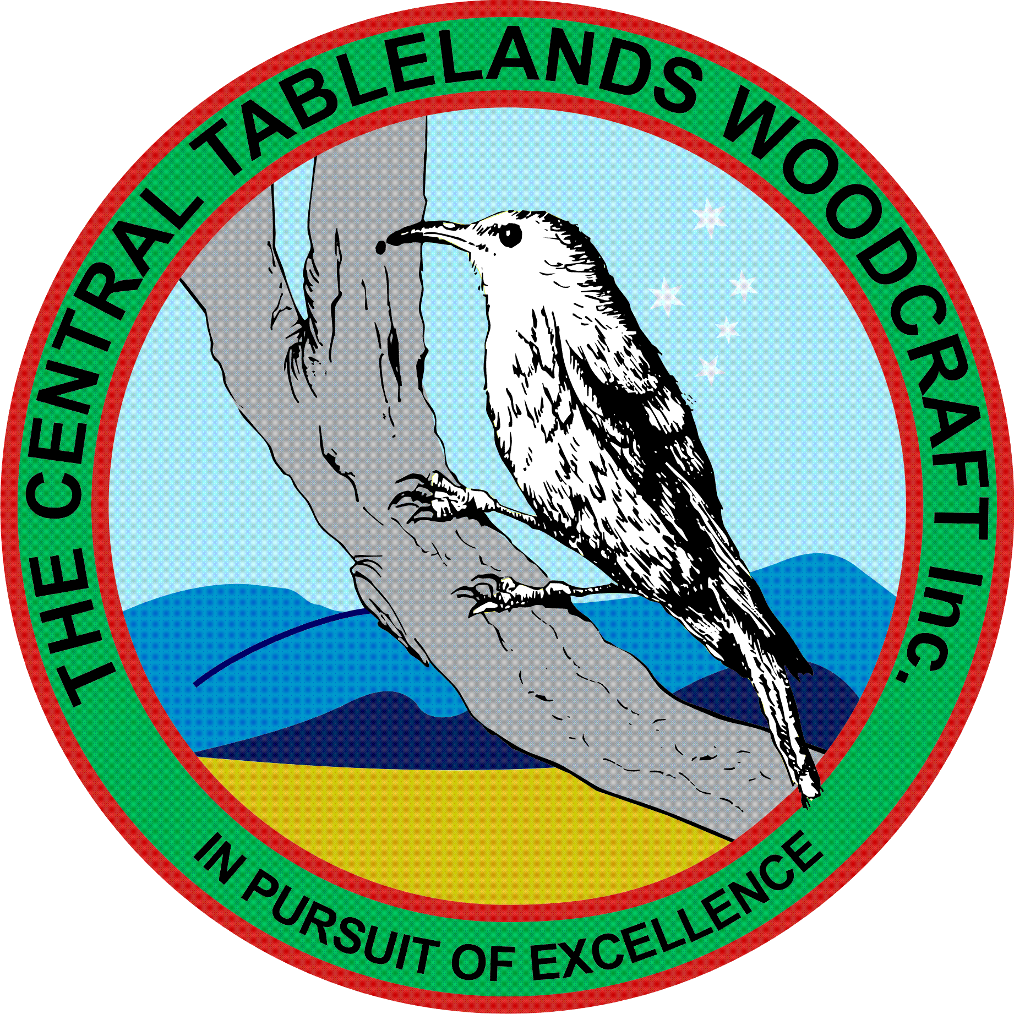
Central Tablelands Woodcraft Newsletter
April/May 2019

First of all, I welcome our President Mike back from his rest following surgery on his knee – great to have you back steering the ship.
As most members are aware the Bathurst Show was held recently, and Ian Jackson attended as the judge for the woodworking competition. It was disappointing that only one member out of over 75 submitted an entry into this competition; it is believed that our members create items of very high standard and could have easily picked up many of the prizes available. Whilst this is not the reason we do our work it is a recognition of our abilities and hard work and a way of learning and improving our skills. The Committee has decided to sponsor a “Best in Show” prize to the value of $200 for next year’s show so over to you members to start creating.
Our attendance at the Heritage Trades Trail was a great success and we not only put on a great display of many lost skills we also sold over $1275 worth of product with $351 going to the Club in way of commissions.
We currently have several projects being undertaken by members of the Club – Knitting Nancies, Staircase Standards, bedhead repair, repairs to two chairs, lid for a baptismal font, honour board for another school, bowling slide for the Seymour Centre. It is wonderful to see so many members participating in these projects and the standard of workmanship being so high – well done guys and gals.
Every second Wednesday people from “Vivability” visit the workshop for some diversional therapy – so far, they/we have made a chopping board for each one of them and Ian Jackson is currently making some simple toys for them to complete. It is very satisfying work.
Ian Jackson and Graham Moon have been undertaking machinery inspections and repairs as required and Graham has been performing electrical tagging and testing – we now have another new member who is an electrician who is helping with this process – keep up the great work.
It is also appropriate to advise ALL members that your fees are now overdue – it is inappropriate to attend the workshop and use the facilities without being a current financial member as you are no longer covered by our comprehensive insurance.
Ron Lebrocque is organising another social event – standby for dates, times and a location.
Many members, especially the newer ones are making good use of the Club facilities and equipment to create items from wood that are of a very high standard and there seems to be a bit of friendly competition creeping in which is great to see and this also leads to our standards getting higher.
Many members are also seeking guidance from the older more experienced members especially on the lathes and in joinery. This has meant that when projects are presented these people are up to the task of either assisting or taking the lead in these projects. As a member of the management team this is very satisfying and shows that our Club is growing.

