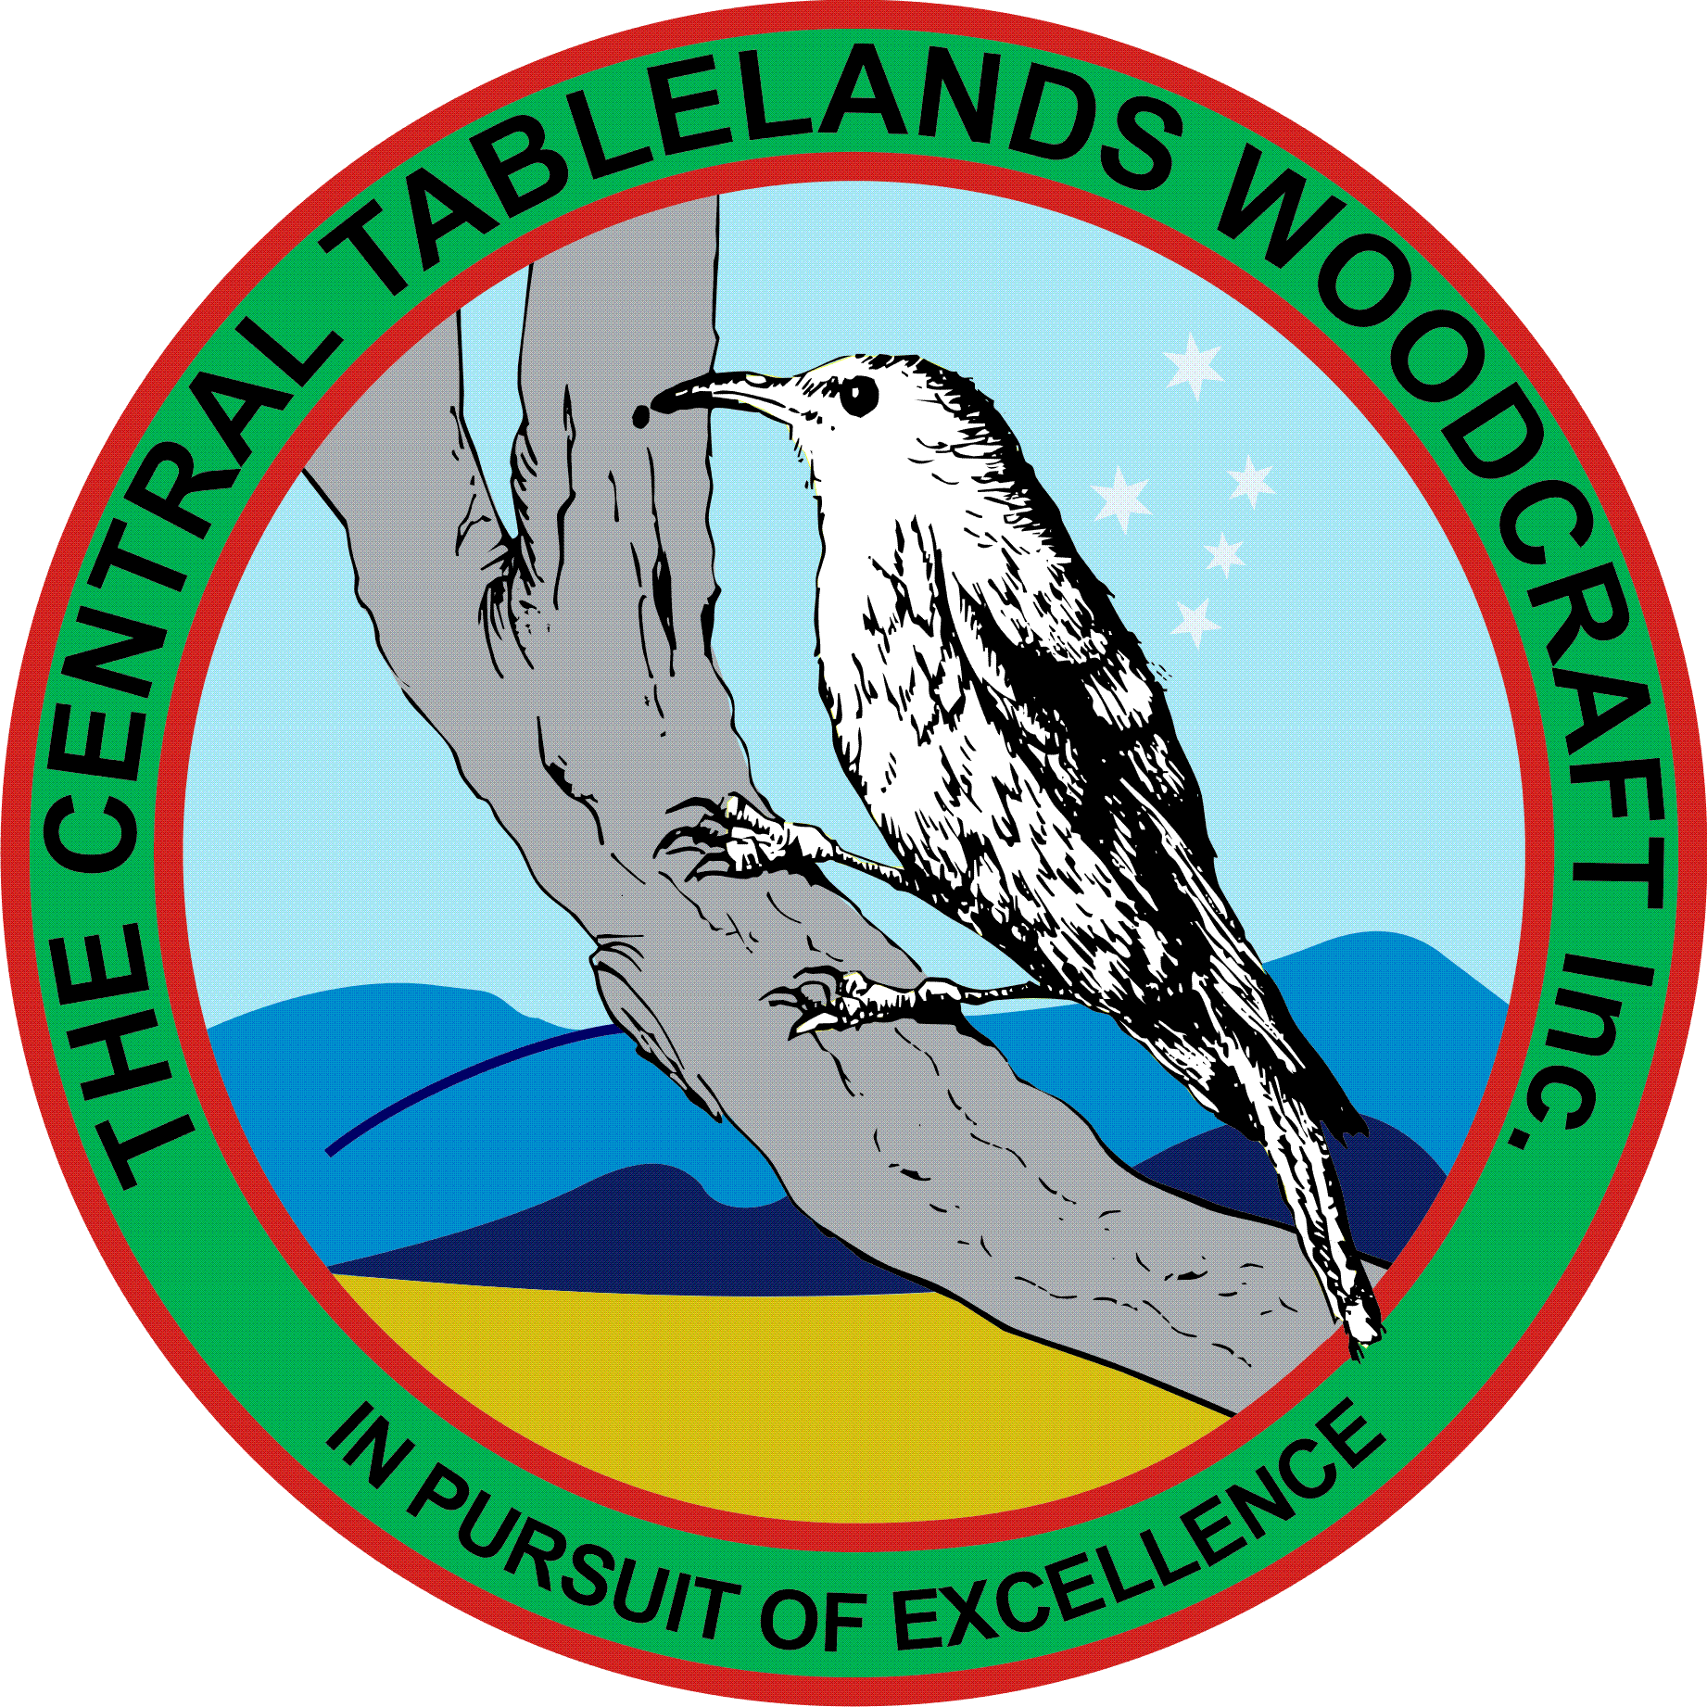
Central Tablelands Woodcraft Newsletter
September 2019
Central Tablelands Constructions has been undertaking the refurbishment of the toilet block and the progress is visible – the floor has been tiled and wall tiling will commence shortly
The proposed voluntary worker insurance has been put in place and the premium paid.
A reminder that with W.O.S coming up in November, it is necessary for members to be making items both for sale and to enter into the competition. Jim and Jacko will be harassing members for competition items over the coming weeks.
Sponsors for W.O.S are coming in with more to follow shortly. Tasks for committee have been allotted and work is proceeding.
A new order for Club shirts has been placed near the sign on sheet and members are encouraged to place orders, however with the issue of members ordering last time and not picking up, we will be collecting full payment prior to orders being placed.
There has been some discussion regarding the kitchen as, with so many members now attending the facilities, there is not enough room. Paddy has commenced this project by stripping out the shelving.
CLUB PROJECTS
- Knitting Nancies Jim Hallahan (ongoing)
- Limber-jacks Colin and Paul (ongoing)
- Name Badge Box for Probus Jacko (underway)
- Indoor Bowling Slide John Mc
- Kitchen Paddy
- Lowering of table Jacko & Peter (completed)
- Darning Mushroom Garth
- Small drawer knobs Bob Baille (completed)

Planning for the Club Christmas Party by Bob Cassidy is underway and will be held on 13 December. The cost has gone up by $5 to $20 per person this year. Moneys will be collected up to 2 weeks prior to the party – their will be no late payments.
Members have been returning raffle tickets and it is great to see that this is receiving such enthusiastic support.
A reminder that ANY item that is presented for sale MUST have a ticket affixed and correctly filled out - if you are unaware of how to do this contact one of your committee members.
Doug has made a support station for the card reader for use at our stalls and W.O.S. Currently we are using his small computer and it has been determined by the committee to purchase a small dedicated laptop device specifically for the purpose.
Several of our members led by Jacko and garth have been working with a group of home-schooled children who have been learning basic woodworking skills. The first project has been a small box with basic joints, glued and nailed and finally fitted with a routed lid. It is also appropriate to mention Bathurst Bunnings for their support in this project. The programme has been going for 2 weeks and still has 3 more weeks to go.

