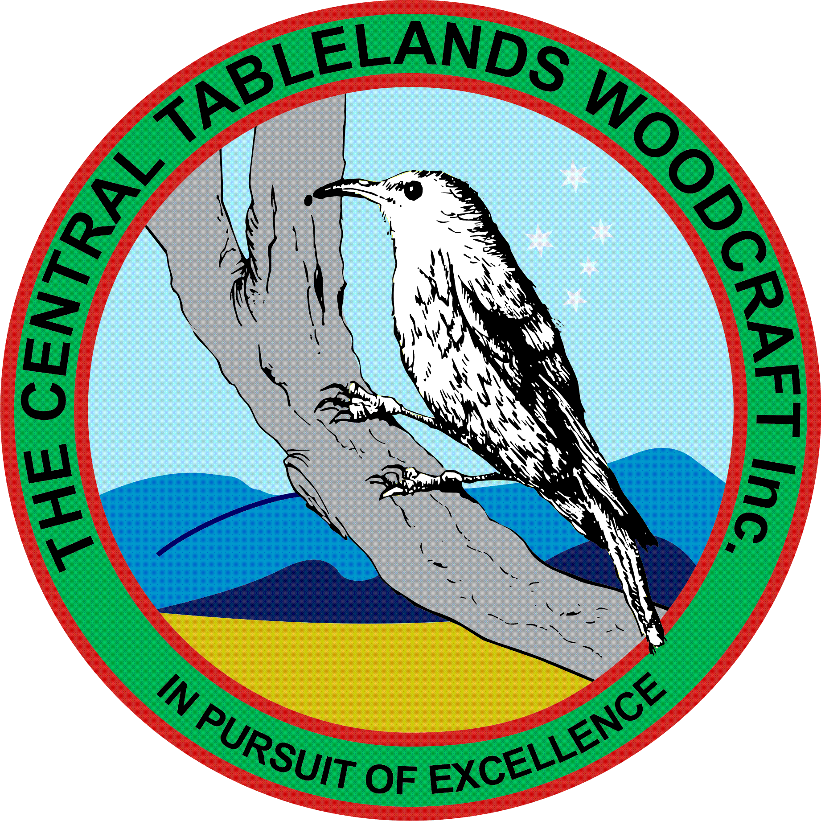
Central Tablelands Woodcraft Newsletter
August 2019
It is difficult to believe that the year is now 8 months old and the winter has been remarkably cold; however, this has not deterred the intrepid woodworkers from attending our facilities.
A tender from Central Tablelands Constructions has been accepted for the refurbishment of the toilet block and work will commence shortly with Council managing the project.
The proposed voluntary worker insurance has been put in place and the premium paid.
There are two pre-Father’s Day events coming up in the following week
- At Bathurst city Centre on Friday 23/8 and Saturday 24/8 with equipment delivery and setup on the Thursday from 1600hrs. In order for us to undertake what we want to do we require some extra power boards.
- At Bunnings on Thursday 29/8 from 1800hrs – ALL members are welcome to attend.
There are also some events that members are involved in and would like others to attend:
- Trivia Night at Magellan Club on Friday 13 September in aid of PCYC.
- Perthville Village Fair on 14 September
At the July meeting there was some discussion surrounding the requirement for members to obtain “Working with Children” clearances however after some investigation by Elizabeth it has been determined that, as a club, this is not necessary. Any individual members who may be working with or supervising people under 16 will require such clearance. Any members who currently hold such certification should advise the Hon. Sec. so that this may be recorded for future reference.
With W.O.S coming up in November, it is necessary for members to be making items both for sale and to enter into the competition. Jim and Jacko will be harassing members for competition items over the coming weeks.
A new order for Club shirts has been placed near the sign on sheet so please indicate you needs so that we can place the order.
There has been some discussion regarding the kitchen as, with so many members now attending the facilities, there is not enough room. It has been decided that Paddy manage this project.
The social lunch that was organised by Ron was well attended and enjoyed by all – thanks Ron.
CLUB PROJECTS
- Knitting Nancies Jim Hallahan (ongoing)
- Limber-jacks Colin and Paul (ongoing)
- Gun Cupboard (shelves made, cleats fitted awaiting finish) Doug, Ian, Graham
- Lid for Baptismal Font Dick Smith
- Chair Restoration (arm carved) Graham
- Honour Board for Perthville School Jacko
- Scout Badge Board (framer made; Perspex fitted) Doug
- Name Badge Box for Probus Jacko
- Indoor Bowling Slide John Mc
- Kitchen Paddy

